Nutrition value for three types of bread
[Name]
[Institution affiliation]
[Course]
[Date]

- The Healthiest Choice
In our home, bread is consumed on a daily basis. The most common type of bread the family usually prefers is the Ezekiel bread. However, as I went to the store to purchase it, I thought it wise to take with me other two types of bread (Flaxseed bread and Rye bread) and compare their nutritional value with that of Ezekiel bread. Surprisingly, I found that Ezekiel bread is the most nutritious of all because it is baked from the sprouted whole grains and with no added sugar as well.
Given the sprouting process in preparing it, Ezekiel bread has an increased bio-availability and amount of vitamins such as vitamin C, as well as minerals that include lysine and folate (Quinn, 2008). Nevertheless, Ezekiel bread remains the most nutritious of all since it is baked with barley, wheat, millet, lentils, and spelt. After such legumes and grains are sprouted and mixed, they lead to a complete protein like that found in eggs and milk. AS, Ezekiel bread is of high-quality, and it contains all the nine significant amino acids. Moreover, the sprouted grains are tolerated more easily by some of my family members with sensitivities of grain protein, because they help in fighting diabetes, protecting them from the leaver disease, and reducing the cardiovascular risk issues. Below is a picture of Ezekiel bread.
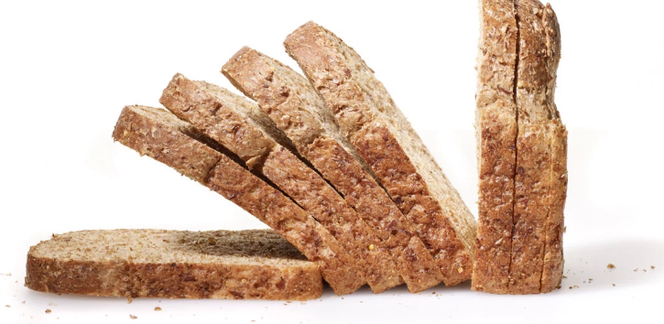
Flaxseed bread is the second nutritious type of bread since it is prepared from sprouted wheat berries and organic whole flax seeds that make the bread to be low in carbohydrates, sodium, and calories (Reinhart, 2014). Besides, Flaxseed bread helps in reducing heart disease risks, stroke, cancer, and diabetes. Rye bread, on the other hand, is baked with rye flour, that is obtained from a plant similar to that of wheat. In terms of nutrition, Rye bread reduces the total cholesterol in the body, slightly improves the sensitivity of the insulin, hence lowering the total body cholesterol. As a result, Rye bread is economic despite being the list nutritious since it reduces hunger and the desire to eat after eight hours. The images for the two types of bread are shown below consecutively.
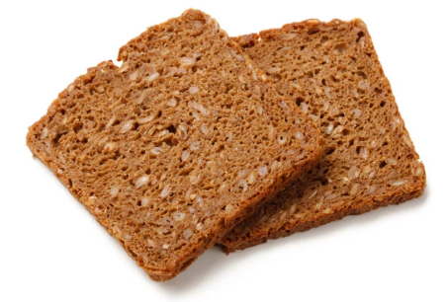
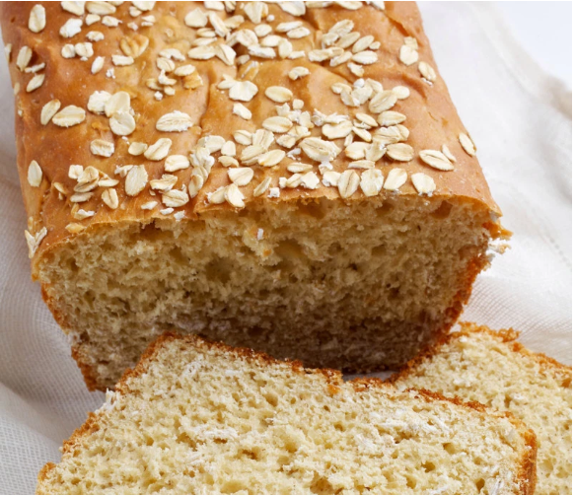
- Cost per Serving
1 slice of Ezekiel bread: 80 calories, 15g carbohydrates, 4g protein, and 0g sugar
2 slices of Flaxseed bread: 100 calories, 19g carbohydrates, 6g protein, and 1g sugar
1 slice of Rye bread contains 90 calories, 16g carbohydrates, 3g protein, and 1g sugar (Reinhart, 2014).
Given such cost per serving, Ezekiel bread is the most nutritious, something that makes it be expensive compared to the other two. The main reason is that the bread is made from legumes and grains that result in a complete protein like that in eggs and milk.
- Top five ingredients in each type of bread
Ezekiel bread is made of water, wheat berries, spelt flour, barley, millet, and green lentils while Flaxseed bread is baked using water, Flaxseed, eggs, coconut oil, and baking powder. However, Rye bread is made from water, dry yeast, sugar, melted butter, egg, warm milk, and vinegar.
When compared to the other two types of bread, Ezekiel bread has barley, millet, and lentils that act as preservatives. Rye bread, however, contains vinegar, an ingredient that is not common in both Ezekiel and Flaxseed bread. The vinegar is used to add flavor to the bread. Nevertheless, all the ingredients in the three types of bread are of great importance; therefore, there is no one that I expect not to find in the bread.

References
Quinn, J. (2008). Essential eating sprouted baking: With whole grain flours that digest as vegetables. Waverly, Penn: Azure Moon Pub.
Reinhart, P. (2014). Bread revolution: World-class baking with sprouted & whole grains, heirloom flours, & fresh techniques.

